SQL Exercise 1

1. Create the table SEMP with the following structure:-

EMPNO CHAR(4)
EMPNAME CHAR(20)
BASIC FLOAT
DEPTNO CHAR(2)
DEPTHEAD CHAR(4)

CREATE TABLE SEMP(
EMPNO CHAR(4),
EMPNAME CHAR(20),
BASIC FLOAT,
DEPTNO CHAR(2),
DEPTHEAD CHAR(4)
);

2. Create the table SDEPT with the following structure:-

DEPTNO CHAR(2)
DEPTNAME CHAR(15)

CREATE TABLE SDEPT(
DEPTNO CHAR(2),
DEPTNAME CHAR(15)
);
3. Insert into the SDEPT table the following values:-

10, Development
20, Training

INSERT INTO SDEPT VALUES
('10','Development'),
('20','Training');

4. Insert into the SEMP table the following values:-

0001, SUNIL, 6000, 10
0002, HIREN, 8000, 20
0003, ALI, 4000, 10, 0001
0004, GEORGE, 6000, 0002

INSERT INTO SEMP VALUES
('0001','SUNIL',6000,'10',NULL),
('0002','HIREN',8000,'20',NULL),
('0003','ALI',4000,'10','0001'),
('0004','GEORGE',6000,'20','0002');

Create S, P, J, SPJ tables as specified below and insert a few rows in each table:-

SUPPLIER
(S#, Sname, Status, City) - S
PARTS

CREATE TABLE S(
`S#` CHAR(3),
SNAME VARCHAR(20),
STATUS INT,
CITY VARCHAR(20)
);

(P#, Pname, Color, Weight, City) - P
PROJECTS
INSERT INTO P VALUES
('P1','Nut','Red',12,'London'),
('P2','Bolt','Green',17,'Paris'),
('P3','Screw','Blue',14,'Rome'),
('P4','Cam','Red',12,'London'),
('P5','Cog','Blue',19,'Athens');

(J#, Jname, City) - J
SUPPLIER-PARTS-PROJECT

CREATE TABLE J(
`J#` CHAR(3),
JNAME VARCHAR(20),
CITY VARCHAR(20)
);

(S#, P#, J#, Qty)
- SPJ

Sample data for S# column:- ‘S1’, ‘S2’, ‘S3’, etc.
Sample data for P# column:- ‘P1’, ‘P2’, ‘P3’, etc.
Sample data for J# column:- ‘J1’, ‘J2’, ‘J3’, etc.
Sample data for Status column:- 10, 20, 30, etc.

Write the SELECT queries to do the following:-
INSERT INTO J VALUES
('J1','Sorter','Paris'),
('J2','Display','Rome'),
('J3','OCR','Athens'),
('J4','Console','Athens'),
('J5','RAID','London');

CREATE TABLE SPJ(
`S#` CHAR(3),
`P#` CHAR(3),
`J#` CHAR(3),
QTY INT
);

INSERT INTO SPJ VALUES
('S1','P1','J1',200),
('S1','P1','J4',700),
('S2','P3','J1',400),
('S2','P3','J2',200),
('S3','P2','J2',200),
('S4','P2','J4',300),
('S5','P5','J5',500);

5. Display all the data from the S table.
SELECT * FROM S;
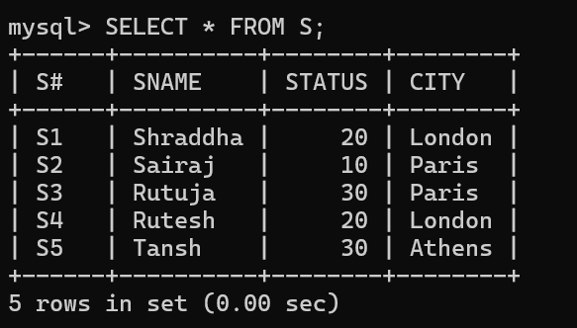
6. Display only the S# and SNAME fields from the S table.
SELECT `S#`, SNAME
FROM S;
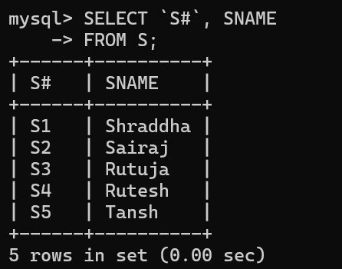
7. Display the PNAME and COLOR from the P table for the CITY=”London”.
SELECT PNAME, COLOR
FROM P
WHERE CITY='London';
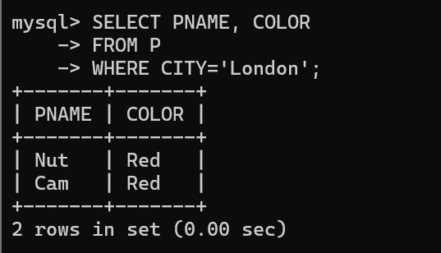

8. Display all the Suppliers from London.
SELECT *
FROM S
WHERE CITY='London';

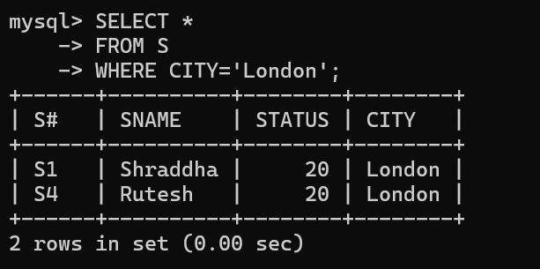
9. Display all the Suppliers from Paris or Athens.

SELECT *
FROM S
WHERE CITY='Paris' OR CITY='Athens';
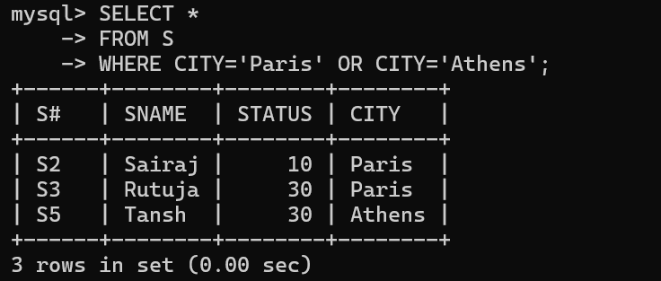
10. Display all the Projects in Athens.
SELECT *
FROM J
WHERE CITY='Athens';
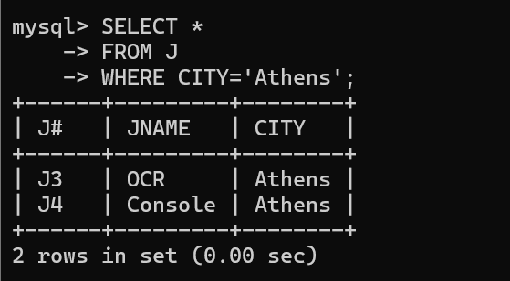
11. Display all the Partnames with the weight between 12 and 14 (inclusive of both).

SELECT PNAME
FROM P
WHERE WEIGHT BETWEEN 12 AND 14;
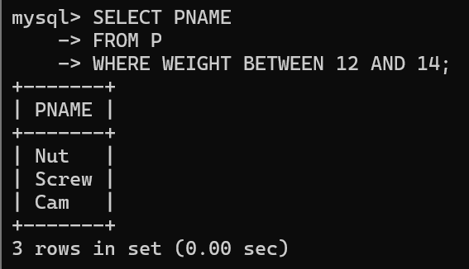
12. Display all the Suppliers with a Status greater than or equal to 20.
SELECT *
FROM S
WHERE STATUS >= 20;
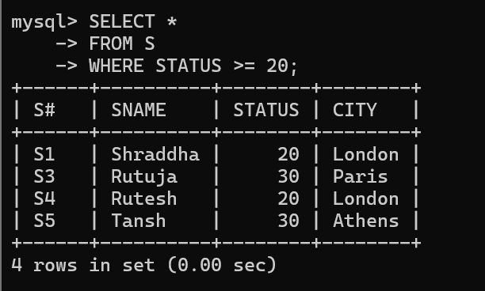
13. Display all the Suppliers except the Suppliers from London.
SELECT *
FROM S
WHERE CITY <> 'London';
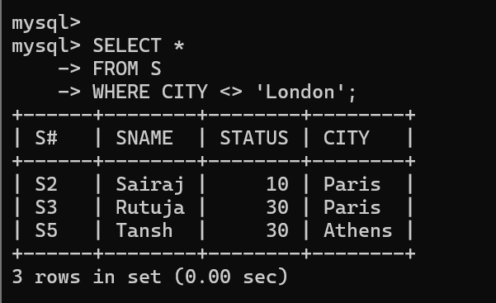
14. Display only the Cities from where the Suppliers come from.
SELECT DISTINCT CITY
FROM S;
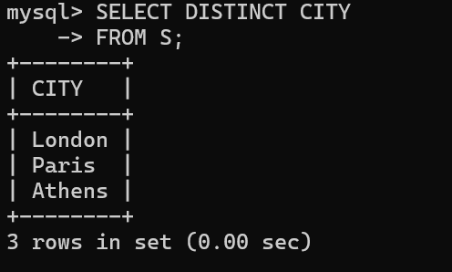

15. Assuming that the Part Weight is in GRAMS, display the same in
MILLIGRAMS and KILOGRAMS
SELECT PNAME,
WEIGHT,
WEIGHT*1000 AS MILLIGRAMS,
WEIGHT/1000 AS KILOGRAMS
FROM P;
